**References:**

* <https://www.mybotic.com.my/products/MQ-7-MQ7-Gas-Sensor-Module-(Carbon-Monoxide-CO)/421>
* <https://components101.com/sensors/mq135-gas-sensor-for-air-quality>
* <https://lastminuteengineers.com/mq2-gas-senser-arduino-tutorial/>

**How does a gas sensor work?**

When tin dioxide (semiconductor particles) is heated in air at high temperature, oxygen is adsorbed on the surface. In clean air, donor electrons in tin dioxide are attracted toward oxygen which is adsorbed on the surface of the sensing material. This prevents electric current flow.

In the presence of reducing gases, the surface density of adsorbed oxygen decreases as it reacts with the reducing gases. Electrons are then released into the tin dioxide, allowing current to flow freely through the sensor.

In our project we have used 3 gas sensors MQ-135, MQ-7 and the most gas sensor MQ-2. Below the features and specifications are written:

**MQ-135 Sensor Features:**

* Wide detecting scope
* Fast response and High sensitivity
* Stable and long life
* Operating Voltage is +5V
* Detect/Measure NH3, NOx, alcohol, Benzene, smoke, CO2, etc.
* Analog output voltage: 0V to 5V
* Digital output voltage: 0V or 5V (TTL Logic)
* Preheat duration 20 seconds
* Can be used as a Digital or analog sensor
* The Sensitivity of Digital pin can be varied using the potentiometer

We have used this gas sensor in our project for the particular pollutants namely for Smoke particles, NOx and CO2.

**MQ-7 Sensor Features:**

* MQ7 is a high sensitivity to carbon monoxide and stable and long-life span.
* circuit voltage: 5V±0.1
* Heating voltage (high): 5V±0.1
* Heating voltage (low): 1.4V±0.1
* Load resistance: Adjustable
* Heating resistance: 33Ω±5%
* Heating time (high): 60±1 seconds
* Heating time (low): 90±1 seconds
* Using temperature: -20°C-50°C
* Storage temperature: -20°C-50°C
* Oxygen concentration: 21%(stand condition) the oxygen concentration can affect the sensitivity characteristic
* Sensitive in clean air

We have used this gas sensor in our project for the particular pollutants namely for CO.

**MQ-2 Sensor Features:**

The MQ-2 gas sensor detects LPG, propane, methane, hydrogen and smoke. We have used it for this pollutant. MQ2 is one of the commonly used gas sensors in MQ sensor series. It is a Metal Oxide Semiconductor (MOS) type Gas Sensor used for the detection of pollutant particle based upon change in resistance of the sensing material when the gas pollutants comes in contact with the material. It’s mechanism is based on simple voltage divider network. This is not breadboard compatible however it is very convenient use. It has two different outputs.

* Operating voltage 5V
* Load resistance 20 KΩ
* Heater resistance 33Ω ± 5%
* Heating consumption less than 800mw
* Sensing Resistance 10 KΩ – 60 KΩ
* Concentration Scope 200 – 10000ppm
* Preheat Time over 24 hour

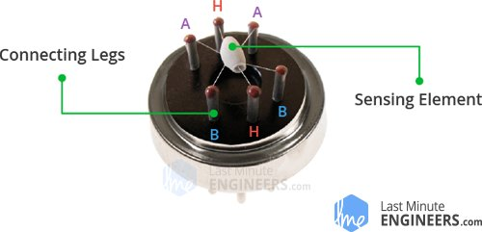

This is how the sensor looks like when outer mesh is removed. The star-shaped structure is formed by the sensing element and six connecting legs that extend beyond the Bakelite base. Out of six, two leads (H) are responsible for heating the sensing element and are connected through Nickel-Chromium coil, well known conductive alloy.